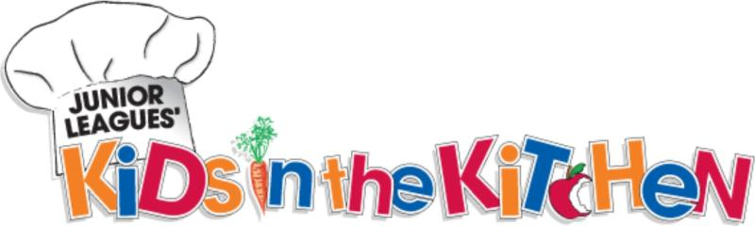

FOR IMMEDIATE RELEASE: Media Contact: Lauren McKechnie
August 3, 2015 281-380-8122
lkmckechnie@gmail.com

Local Elementary Kids Become Healthy Chefs at the Junior League’s “Kids in the Kitchen” Day on August 7

Wichita Falls, TX (August 3, 2015) – Volunteer leaders from The Junior League of Wichita Falls, Inc. (JLWF) will host an afternoon of health education and fun at The Central Boys & Girls Club on Friday, August 7, 2015 from noon to 3:30 p.m. As part of the Junior League’s “Kids in the Kitchen” outreach program, elementary-aged children will learn about food groups and healthy diet, become chefs through a healthy food preparation lesson, and compete in fitness activities that promote a healthy lifestyle. Each child will be given a goodie bag and be entered for a chance to win a free bicycle.
“This event marks the start of our ninth year to provide Kids in the Kitchen classes to our neighbors in Wichita Falls,” said Sierra Wells, Kids in the Kitchen Chair for The Junior League of Wichita Falls. “In the Junior League we are focused on making the community better and helping children in need, and being able to witness how these classes make an impact on each child’s long-term health and wellbeing is such a privilege.”
The goal of the Junior League’s “Kids in the Kitchen” program is to promote child health and wellness by empowering children and youth to make healthy lifestyle choices, therefore preventing obesity and its associated health issues. For more information on upcoming events and information on how the Junior League of Wichita Falls supports our local community through acts of service, visit www.jlwf.org.
###
The Junior League of Wichita Falls, Inc. is an organization of women committed to promoting voluntarism, developing the potential of women, and improving our community through the effective action and leadership of trained volunteers. Our purpose is exclusively educational and charitable.

